SIMATS ENGINEERING
ASSESSMENT TOOL 1: Experiments
COURSE NAME: Cloud Computing and Big Data Analytics COURSE CODE: CSA15
COURSE OUTCOME COVERED
CO3: Implement cloud-based solutions using cloud storage, web APIs, and platform services for real-world applications. (BL3)
Dave's Taxonomy: Precision (Level 3) Total Marks: 40
Question Count: 4
Code of Conduct
I S.SHAMAH ALI FATHIMA(192573002) (Name / Reg No) certify that this submission is my original work and that I have adhered to the guidelines specified for this assessment.
I understand that any violation of academic integrity rules will result in disciplinary action.
Signature of the student: 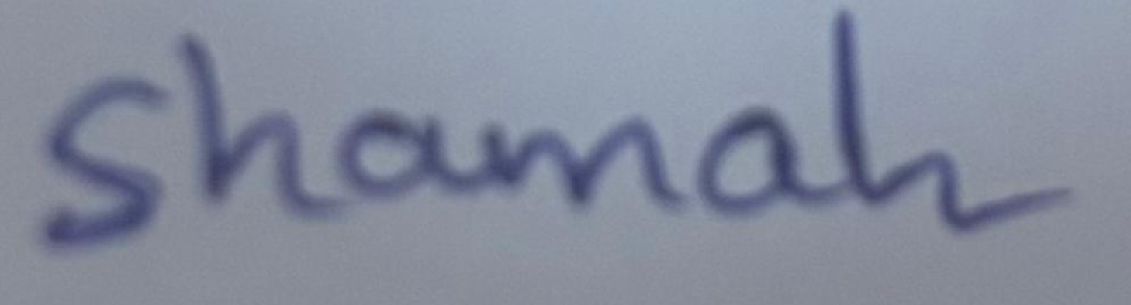
Experiments Rubric
Criteria | Weightage | Level 4 - Exemplary | Level 3 - Proficient | Level 2 - Developing | Level 1 - Beginning
Experimental Design | 25% | Design is systematic and technically strong | Mostly correct design | Basic design with gaps | Poorly designed activity
Use of Tools / Platforms | 20% | Appropriate and effective use of cloud tools | Good tool usage with minor issues | Limited tool usage | Incorrect or missing tool usage
Application of Concepts | 20% | Concepts are applied accurately to practical tasks | Mostly accurate application | Partial application | Weak application
Analysis and Output | 20% | Strong analysis and meaningful outcome interpretation | Good analysis with minor gaps | Basic analysis | Little or no analysis
Documentation | 15% | Clear, structured, and complete documentation | Mostly complete documentation | Partially complete documentation | Poor documentation
Total Marks Awarded: ____________________

Set 1 - Assessment Tasks
Experiments
Experiment 1
Create a simple cloud software application for Library book reservation system for SIMATS library using any Cloud Service Provider to demonstrate SaaS include the necessary fields such as Title of the book, author, publications, Year, edition, no of copies, Rack no, status (taken/returned) etc.
Experiment 2
Create a simple cloud software application for Payroll Processing System using any Cloud Service Provider to demonstrate SaaS include the necessary fields such as Name of the employee, experience in present org, overall experience, basic pay, HRA, DA, TA, net pay, gross pay etc.
Experiment 3
Demonstrate virtualization by Installing Type-2 Hypervisor in your device, create and configure VM image with a Host Operating system (Either Windows/Linux). Create a Virtual Machine with 1 CPU, 2GB RAM and 15GB storage disk using a Type 2 Virtualization Software.
Experiment 4
Demonstrate virtualization by Installing Type-2 Hypervisor in your device, create and configure VM image with a Host Operating system (Either Windows/Linux). Create a Cloning of a VM and Test it by loading the Previous Version/Cloned VM.

Set 2 - Assessment Tasks
Experiments
Experiment 1
Create a simple cloud software application for Hospital information system for SIMATS Hospital using any Cloud Service Provider to demonstrate SaaS with fields of patient name, age, address, phone, email, Attender name, attender phone, doctor name, diseases, etc.
Experiment 2
Create a simple cloud software application for online super market using any Cloud Service Provider to demonstrate SaaS with the template of customer name, address, phone, email, items, quantity etc. with the item classification form.
Experiment 3
Demonstrate virtualization by Installing Type-2 Hypervisor in your device, create and configure VM image with a Host Operating system (Either Windows/Linux). Create a Virtual Machine with 3 CPU, 10GB RAM and 10GB storage disk using a Type 2 Virtualization Software.
Experiment 4
Demonstrate virtualization by Installing Type-2 Hypervisor in your device, create and configure VM image with a Host Operating system (Either Windows/Linux). Create a Snapshot of a VM and Test it by loading the Previous Version/Cloned VM.

Set 3 - Assessment Tasks
Experiments
Experiment 1
Create a simple cloud software application for Mark Sheet Processing System using any Cloud Service Provider to demonstrate SaaS include the necessary fields such as name of the student, Reg no of the student, Subjects, Marks, Average, percentage, rank, overall performance etc.
Experiment 2
Create a simple cloud software application for Property Buying & Rental process (In Chennai city) using any Cloud Service Provider to demonstrate SaaS include the necessary fields such as Buy, Rent, commercial, Rental Agreement, Area, place, Range, property value etc.
Experiment 3
Demonstrate virtualization by Installing Type-2 Hypervisor in your device, create and configure VM image with a Host Operating system (Either Windows/Linux). Create a Virtual Machine with 5 CPU, 12 GB RAM and 8 GB storage disk using a Type 2 Virtualization Software.
Experiment 4
Demonstrate virtualization by Installing Type-2 Hypervisor in your device, create and configure VM image with a Host Operating system (Either Windows/Linux). Create a Snapshot of a VM and Test it by loading the Previous Version/Cloned VM.

EXPERIMENT 1: MARK SHEET PROCESSING SYSTEM USING SaaS
AIM:
To create a simple cloud software application for a Mark Sheet Processing System using a cloud service provider and display student marks, average, percentage, rank, and overall performance.
SOFTWARE / REQUIREMENTS:
Zoho Creator account, web browser, and internet connection.

PROCEDURE:
- Sign in to Zoho Creator and create a new application from scratch.
- Name the application “Mark Sheet Processing System”.
- Create a form with Student Name, Register Number, Subject Marks, Total Marks, Average, Percentage, Rank, and Overall Performance fields.
- Configure calculations or form workflows to calculate total marks, average, and percentage automatically.
- Add suitable performance categories and configure rank based on students’ total marks.
- Create a report to display the submitted student records.
- Enter sample student details, save the record, and verify the calculated output.

OUTPUT:
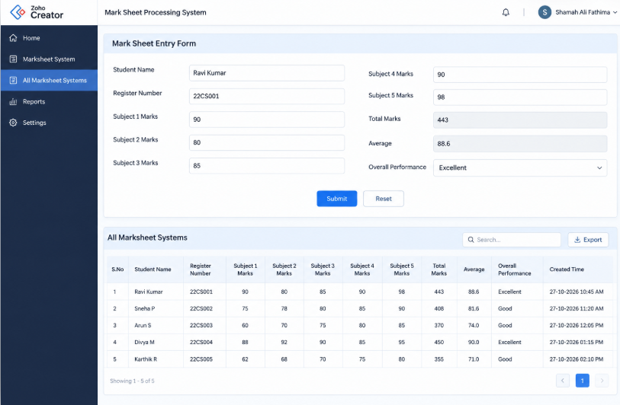
RESULT:
The Mark Sheet Processing System was created using a cloud platform. Student details and marks were entered, and the results were displayed in a report.

EXPERIMENT 2: PROPERTY BUYING AND RENTAL SYSTEM USING SaaS

AIM:
To create a cloud-based application for managing property buying and rental details in Chennai using a cloud service provider.
SOFTWARE / REQUIREMENTS:
Zoho Creator account, web browser, and internet connection.

PROCEDURE:
- Sign in to Zoho Creator and create a new application named “Property Buying and Rental System”.
- Create a property form with Property ID, Owner Name, Property Type, Process, Rental Agreement, Area, Place, Price Range, Property Value, and Contact Number fields.
- Set Property Type choices to Residential and Commercial.
- Set Process choices to Buy and Rent, and Rental Agreement choices to Yes and No.
- Create a report to display the submitted property records.
- Enter sample property details for a property located in Chennai and save the form.
- Open the report and verify that the property details are displayed correctly.

OUTPUT:
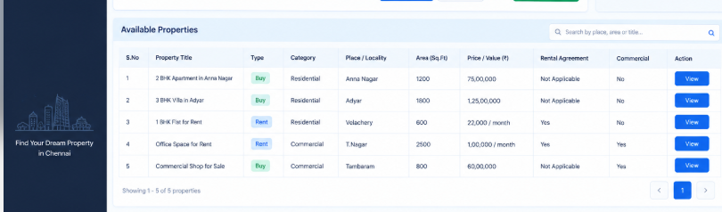

RESULT
The Property Buying and Rental System was created successfully, and property buying and rental details were stored and displayed through the cloud application.

EXPERIMENT 3: INSTALLATION OF TYPE-2 HYPERVISOR AND VM CONFIGURATION
AIM:
To install a Type-2 hypervisor and create and configure a virtual machine with the required CPU, RAM, and virtual disk settings.
SOFTWARE / REQUIREMENTS:
Computer with supported hardware, Oracle VirtualBox, and an operating system ISO file.

PROCEDURE:
- Download Oracle VirtualBox from https://www.virtualbox.org/wiki/Downloads.
- Install VirtualBox on the host operating system.
- Download a suitable operating system ISO file, such as Ubuntu, if permitted by the system requirements.
- Open VirtualBox, select New, and enter a name for the virtual machine.
- Attach the operating system ISO file and configure the VM hardware.
- Set the requested configuration to 5 CPUs, 12 GB RAM, and an 8 GB virtual disk only if the host hardware and selected OS support it.
- Start the VM and follow the operating system installation steps.
- Verify the VM settings and show the running virtual machine.

OUTPUT:
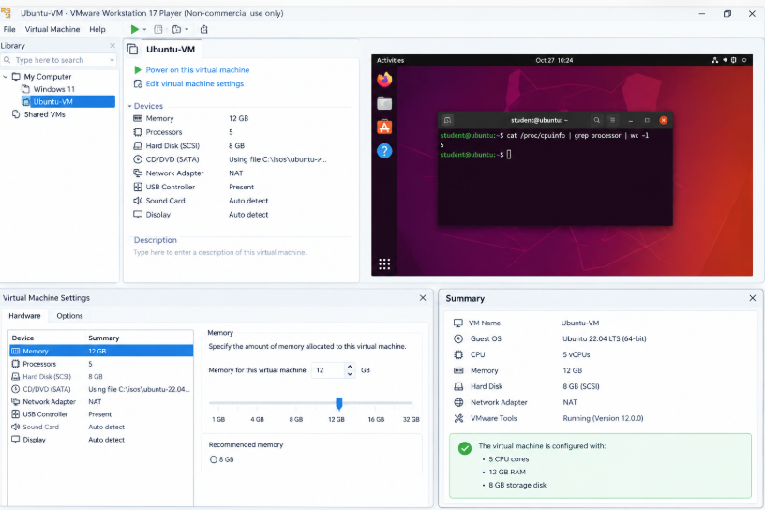

RESULT:
The Type-2 hypervisor was installed and a virtual machine was created and configured. The actual configuration used should be recorded and shown in the screenshots.

EXPERIMENT 4: VM SNAPSHOT CREATION AND RESTORATION

AIM:
To create a snapshot of a virtual machine and restore the previous saved state using a Type-2 hypervisor.
SOFTWARE / REQUIREMENTS:
Oracle VirtualBox and the virtual machine created in Experiment 3.

PROCEDURE:
- Open VirtualBox and select the virtual machine created in Experiment 3.
- Start the VM and confirm that the operating system is working.
- Shut down the VM properly and open the Snapshots view in VirtualBox Manager.
- Select Take Snapshot and name it “Before Changes”. Add a short description if required.
- Start the VM again and make a harmless test change, such as creating a temporary text file.
- Shut down the VM and return to the Snapshots view.
- Select the “Before Changes” snapshot and choose Restore.
- Confirm the restore operation if prompted, start the VM, and verify that the test change is no longer present.

OUTPUT:
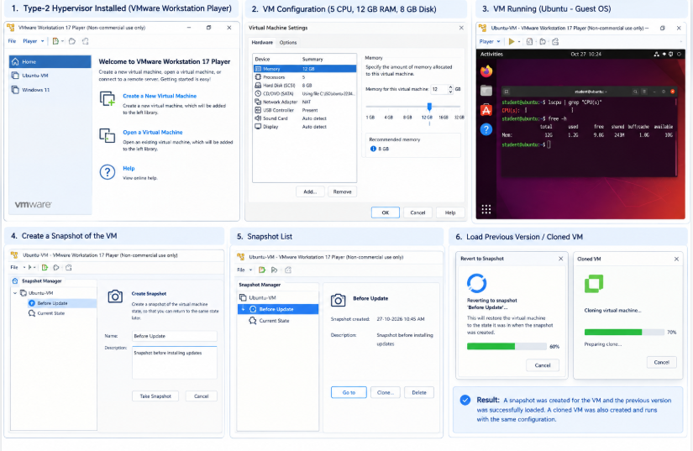

RESULT:
A snapshot was created and restored successfully. The VM returned to the saved state from before the test change.

